3D reconstruction: matching + reconstruction

Keypoint: one of the features

종류: 위치, RGB, Depth…

Feature extraction + Feature matching

Transform matrix

Cartesian coordinate 데카르트 좌표계 X Y Z

Euler angle roll, pitch, Yaw

* Rotation around the front-to-back axis is called **roll**.
* Rotation around the side-to-side axis is called **pitch**.
* Rotation around the vertical axis is called **yaw**.

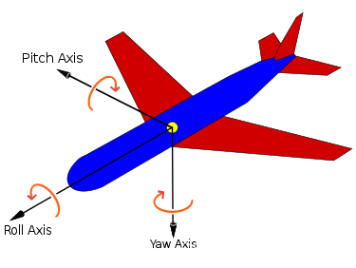

Car: east, north, upper

Airplane: north, east, down

We can get x, y and yaw information from Top view.

Quaternions

matrix representation

Gimbel lock 짐벌락 万向锁

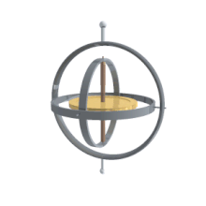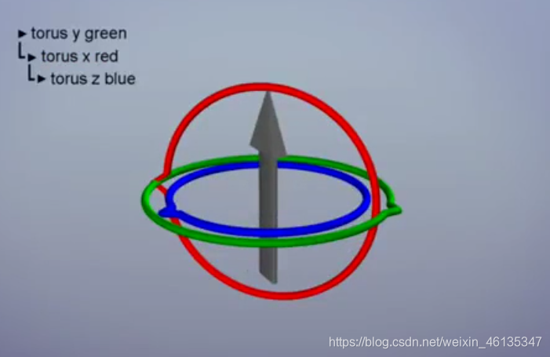

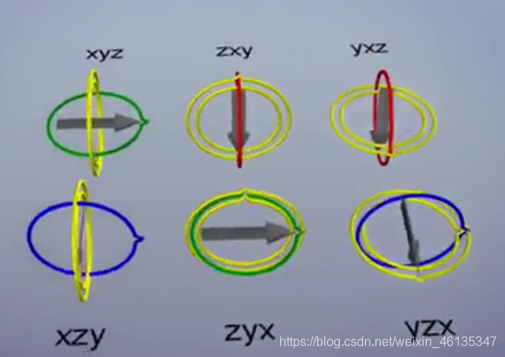

Gimbal lock문제로 인해 세 번째 회전이 첫 번째 회전과 동일한 효과가 발생합니다

When pitch = ±90°

피하는 법

1. The heading value range is (-pi, +pi), and the pitch value range is (-pi/2, +pi/2),
2. 설계한 물체의 피치를 pi/2로 회전할 필요가 없는 방향으로 배치해 보십시오;
3. Why does only Euler angle have deadlock problem?

Because when only Euler angle (zyx order) describes rotational motion, there are constraints in its equation, and pitch cannot be ±90°, while there are no constraints in rotation matrix differential equation and quaternion differential equation. The elements in their equations are angular velocity, which can be selected at will, and the equation is still valid.

The characteristics of the three expressions:

① Euler angle is the most intuitive, easiest to understand, and requires less storage space, but Euler angle has disadvantages such as universal lock phenomenon and uneven interpolation speed, and cannot be directly calculated in the computer;

② Four elements do not have universal lock problem, spherical interpolation can be used to obtain uniform rotation speed, and storage space is also less, but it is difficult to understand and not intuitive;

③ The rotation matrix method is the most convenient for computer processing, but it cannot be directly interpolated, has a lot of redundant information, consumes storage space, and is also not intuitive.

Therefore, in robotics, Euler angles are generally used in human-computer interaction, quaternions are used for interpolation, and matrix representation is used in forward and inverse kinematics operations.

Odometry:

2D plane, find F_{t-1} to F_{t}, integral → current t

VO Visual Odometry

Fps issue → 30fps/sec, too low ↓

Inertial sensor

Offer acceleration and angular velocity,

But meanwhile offer noise and bias as well

+ vision & drift ↓

VIO Visual-Inertial Odometry

다음 월요일 까지:

예준씨:

1. Transform matrix 구현, ground truth 와 대비
2. Docker container 에 실행?

정균:

Sat2Graph 논문 연구

Superpoint 선정시 운동한 object (차량 등)제거

为什么只有欧拉角有死锁问题？

因为只有欧拉角(zyx顺序)描述旋转运动时，其方程中存在约束，pitch不能为±90°，而旋转矩阵微分方程，和四元数微分方程则不存在约束，他们的方程中的元素都是角速度，角速度可以随意选取，方程依然有效。

三种表达各自的特点：

① 欧拉角最直观、最容易理解、存储空间少，但是欧拉角存在万向锁现象、插值速度不均匀等缺点，而且不可以在计算机中直接运算；

② 四元素不存在万向锁问题、利用球面插值可以获得均匀的转速、存储空间也较少，但是不好理解、不直观；

③ 旋转矩阵法是最便于计算机处理的，但不可以直接插值、冗余信息多、费存储空间，同样不直观。

所以，在机器人学中，一般人机交互端会用欧拉角，插值等用四元数，正逆运动学运算中用矩阵表示法。

3.如何避免万向锁问题？

① heading取值范围在（-pi,+pi），pitch取值范围为（-pi/2,+pi/2），或者直接这么理解：尽量将你所设计的物体Pitch置于不需要旋转到pi/2的方向上；